‘QR Scheduler™’ available on the Apple App Store and the Android Market in Google Play
BLOOMINGTON, ILLINOIS – January 31, 2013 -- GK Technology Solutions is excited to announce the release of the smartphone and tablet application, QR Scheduler™. Through the unique QR Scheduling™ process, anyone can transform a schedule of events into a specific QR barcode for quick and easy dissemination. Once scanned with the QR Scheduler app, the schedule corresponding to that barcode is loaded into the calendar of the user’s choice in seconds.
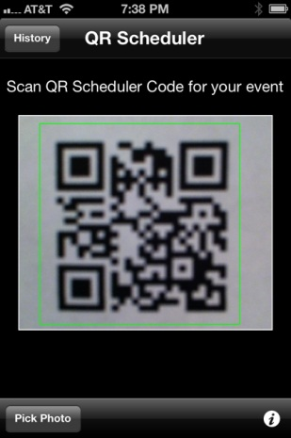
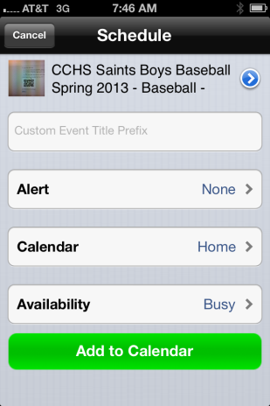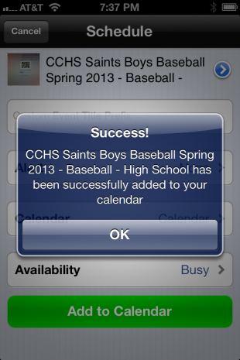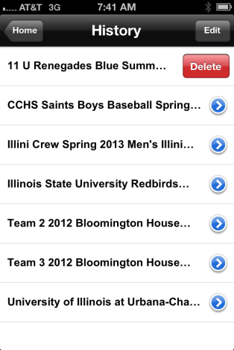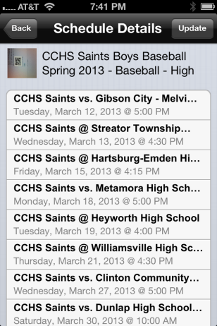
Frustrated with entering our children’s sports and activities schedules into a smartphone calendar using the device's miniature keypad, we developed the QR Scheduling process. For no cost, any consumer can create a QR Scheduler barcode at www.qrscheduler.com which corresponds to a specific schedule. Sharing that barcode with interested individuals is as easy as using the cut, copy and paste function. We created this process not only with the knowledge that it will greatly simplify our busy lives but also with the hope that it will benefit other over-burdened parents as well.
Scanning the barcode with QR Scheduler not only loads the associated events into the calendar of the user’s choice but also gives the end user the option of creating a custom name for the schedule and setting desired alerts. All schedules loaded through this process are stored in the app’s History screen. From the History screen, the user can remove any given schedule from their calendar or open the schedule to view the Schedule Details. The Update function on the Schedule Details screen allows the user to determine if any changes have been made to the schedule.
QR Scheduler is available for $2.99 in the US. Please visit www.qrscheduler.com for more information, including a more thorough explanation of the QR Scheduling process. QR Scheduler applications for Apple and Android devices were developed by GK Technology Solutions Partners, Inc., a web and mobile development company founded in 2012.
If you would like further information on QR Scheduler, would like to schedule an interview, or are a reviewer seeking a promotional code please contact:

David Kaminski, General Counsel
Phone: (312) 203-4523
Email: gk@qrscheduler.info

